**Preliminary Implementation Study Plan**

**Group 9 – CubeSAT**

**Sponsor:**

Dr. Sklivanitis

**Members:**

Jonathan Mazurkiewicz

Zee Fisher

David Milosecki

Morgan Benavidez

Carson Van Buren

**Block Diagram:**

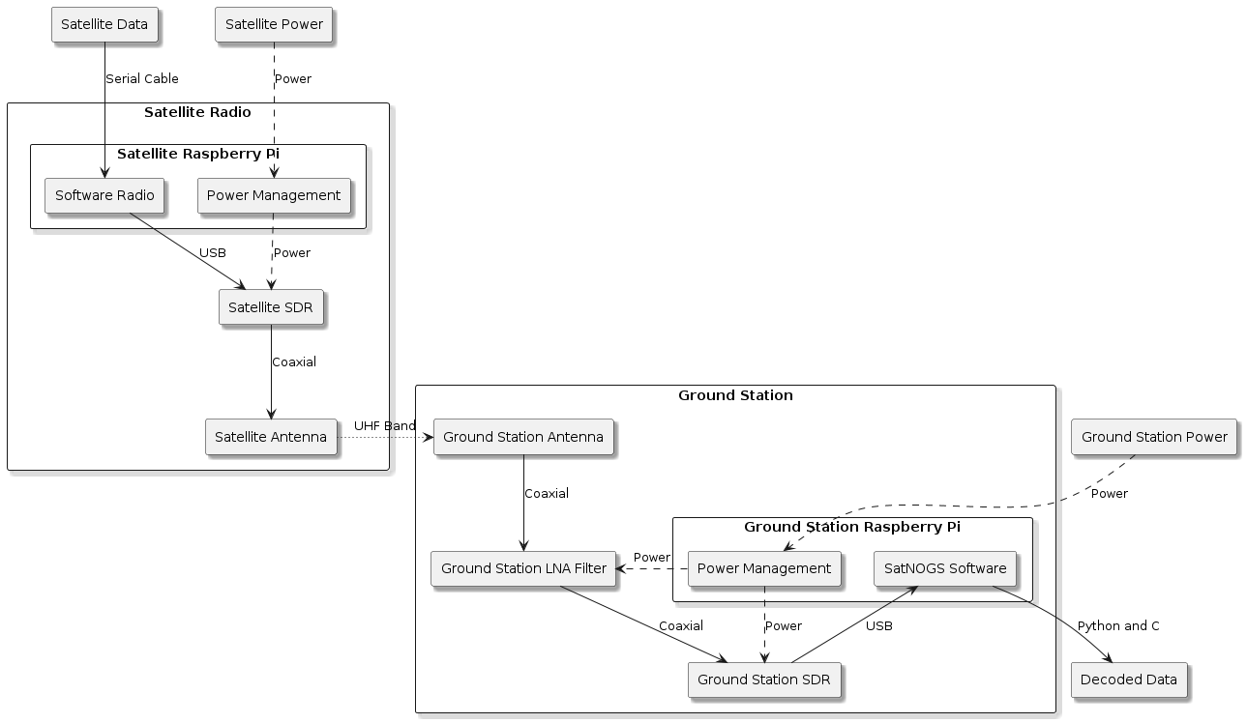

**Overview:**

The purpose of our communication system is to establish communication from a CubeSAT to the ground station. This project is collaborative with the Biology and Mechanical Engineering departments. However, we will only be dealing with the communications system between the satellite and a ground station.

To achieve successful communication, we will leverage Software Defined Radio (SDR). SDR provides a flexible way to transmit and receive RF signals while staying inside of power and size constraints. We will need to determine a communication protocol and modulation strategy effective for the needs of our project.

Simultaneously, we will need to build a ground station capable of receiving this signal. This will also involve an SDR and microcontroller that uses SatNOGS software to decode the data. SatNOGS also provides a base template for setting up a ground station. Possible issues involve signal attenuation, interference, lost data transmissions, and other unforeseen circumstances.

Simulation will be a large component of our project. MATLAB and GNU Radio will be responsible for modeling complex topics such as power consumption, antenna gain, modulation techniques, encoding, and decoding amongst others. These simulations will provide proof of concept before ordering parts and testing.

Finally, we will implement our approach on a CubeSAT built by the Mechanical Engineering team in a launch. There will be a weather balloon sent up to roughly 130,000 feet. This will be the test that proves if we were able to successfully model communications from satellite to ground before the project progresses to an actual space launch.

Component 1: Satellite Defined Radio (SDR)

Name: Jonathan Mazurkiewicz

Description:

Radio transmissions were transmitted and received with analog components in the past. These hardware components lacked versatility and effectiveness. In many space-related applications, significant improvements have been made to allow Software Defined Radio (SDR) to replace these analog components. The digital signal processing, filtering, and communication between devices can be handled by what is known as SDR with greater efficacy, accuracy, speed, and versatility.

It will be my aim to work within the design constraints to select an SDR with the correct capabilities. This will involve significant research into the functionality of SDR, understanding the implementation, and configuring for use. Topics like power consumption, frequency band, modulation techniques, and signal processing will need to be researched in-depth in order to find a suitable solution for CubeSAT communication.

The typical dataflow for SDR is as follows: Data encoded and formed into pulses. Then, it is modulated, with possible additional signal processing like up-sampling before being sent to a digital-to-analog (DAC) and being transmitted. To receive data, this process is reversed (analog-to-digital converter (ADC), optional signal processing, demodulation, and decoding). We will be exploring possible ways to optimize this generic approach for the needs of the project.

Relation to Main Project:

To establish a communication link for a CubeSAT, physical space and power consumption are key factors. In addition, finding the way to be able to successfully transmit data at greater distances with these constraints can be solved with the proper setup of SDR. By selecting the right components and configuring the SDR, a high-speed/reliable communication network can be realized.

Component 2: Raspberry Pi on board the Satellite

Name: Morgan Benavidez

Description: I will be familiarizing myself with the microcontroller on board the satellite that will connect with the SDR. I will also be writing the software that takes data from the satellite and pre-processes it for transmission. A deeper understanding of encoding/decoding and modulation is required to successfully complete this task, and so I will be continuing my education in these topics.

Relation to Main Project: This component is crucial to successfully collect the mission data, pre-process it and send it from the satellite to the ground station.

Component 3: Complete Satellite Radio Subsystem

Name: Zee Fisher

Description: The complete satellite radio subsystem includes Raspberry Pi, Satellite Antenna, Satellite SDR, and their respective connections and power input. Functionally, it involves collecting data from the rest of the satellite via a route TBD. On Board the Raspberry Pi, data will be processed via Component 2. The Raspberry Pi must be connected to the SDR and Antenna. Once fully connected it will send data along the S-Band at a frequency and on a specification both TBD.

Relation to Main Project: This component (and its subcomponent Component 2) is one half of the full system. Without this system the software radio on the satellite would have no way of functioning, and the satellite would have no method of relaying data to the ground station.

Component 4: MATLAB Simulation

Name: David Miloseski

Description: MATLAB simulations offer a powerful and versatile toolset for testing and optimizing the performance of radio ground stations and satellites. In the context of satellite communication, MATLAB allows engineers to model various aspects of the communication link, including signal propagation, atmospheric effects, and antenna characteristics. By employing realistic channel models and incorporating factors such as fading and interference, engineers can simulate the behavior of the radio link under different conditions. This enables thorough testing of the system's robustness and performance in scenarios ranging from clear-sky communication to adverse weather conditions. Additionally, MATLAB facilitates the design and analysis of ground station and satellite communication protocols, helping engineers refine their systems to achieve optimal data transfer rates, reliability, and overall efficiency. Through MATLAB simulations, engineers can identify potential issues, assess system vulnerabilities, and iteratively enhance the design before implementing it in real-world scenarios, ultimately contributing to the development of more reliable and resilient satellite communication systems.

Relation to Main Project: The simulation will let us test how our equipment will work before having to buy anything. This allows us to see if what hardware we wish to implement will work towards our final goal without purchasing anything.

Component 5: Ground Station

Name: Carson Van Buren

Description: The ground station is comprised of a Yagi antenna, low noise amplifier, software defined radio, Raspberry Pi 3 B, and the SatNOGS software image. Our antenna is a 3 element Yagi directional antenna capable of 400-470 MHz(UHF) radio communications and will initially be used to collect data from existing satellites to provide example data for us to reverse engineer. Our low noise amplifier is a Nooelec Lana which filters out unwanted radio noise, like nearby FM stations and helps focus onto our desired signals. Our software defined radio is an RTL-SDR v3 which is a cheap, yet versatile SDR which is compatible with the Raspberry Pi and the SatNOGS software. The SatNOGS software helps us by calculating nearby satellites and best times to observe them, as well as capturing data, decoding data, and presenting that data in a user-friendly GUI. The Raspberry Pi is necessary to run the SatNOGS software and to use the SDR.

Relation to Main Project: The ground station subsystem enables us to collect telemetry data in real time from our satellite and present it/store it. Additionally, it helps us understand the communications requirements for our satellite.